**NAÏVE BAYES POC**

**IMPLEMENTATION:**

Applied Naïve Bayes to identify a fraud detection data model by preparing the mock data of Real Time transactions say ATM/POS/ECOM channels.

**DATA SOURCE:**

The below data-source is being used for our **NAÏVE BAYES** Model.



**Dataset Analysis:**If we observe the below mock data holds the information of transactions.

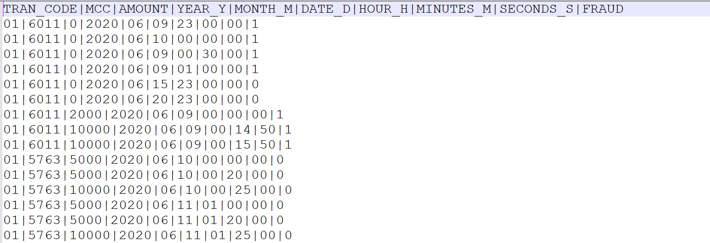

**Group By(Independent Variable):**

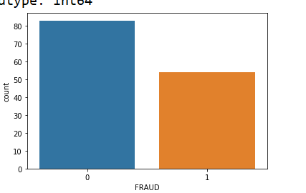

**Confusion Matrix:**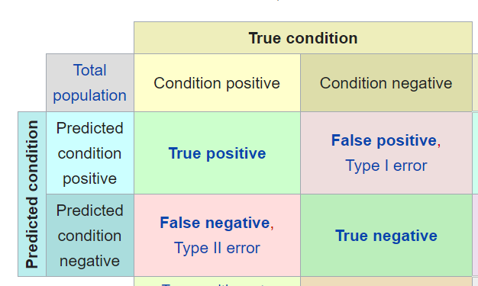

**Confusion Matrix Result:**

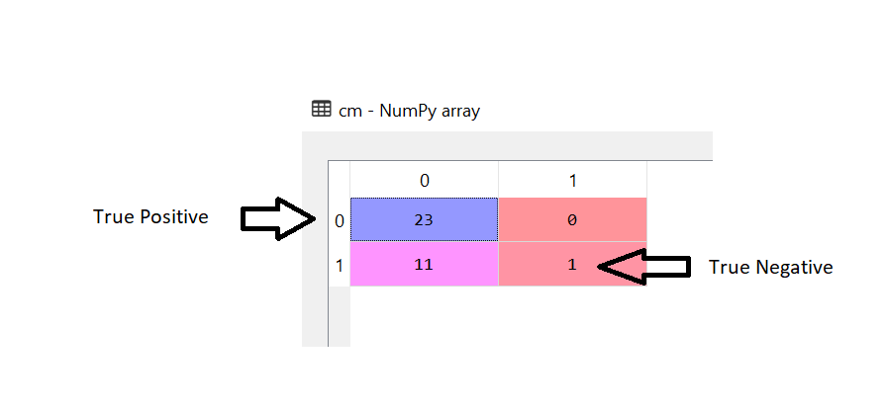

**Accuracy:**Our Naïve Bayes model throws **86%(round-off)** accuracy in the mock dataset prepared.